OrangeRoshan’s SRDC method

This is the simplest way to make profits in forex trading known to me. Even my grandmother, when she is still alive (bless her soul), can also trade effectively. It is also very profitable. I think many professional traders use this method.

It can be applied to all trading platform and need very minimal training or experience in forex. The reason is because this method doesn’t use any indicator at all. All you need to know is how to draw 3 types of line:

- Support
- Resistance
- Trendline

Before the Internet trading era, we trade currencies based on fundamentals and the use of the three lines. Now, I don’t see why we still cannot use it.

The Daily Chart

Has anyone studied the daily chart lately? I have a friend who trade mostly on Daily chart only. His name is Warren Buffet, you might know him! Heheheee….

Now, open your daily chart (candlestick preferably) on your favourite major pair and watch closely. Take 1 minute and tell me what you notice (Don’t read the text below yet)?

THERE IS NOT A SINGLE BAR EQUAL TO THE BAR NEXT TO IT!

Based on this fact, we can safely assume that, the highs and lows of a daily candles are unique EVERYDAY (daaaaa…).

Now do this:

- Draw support and resistance on any of the previous bar. For newbies and JaJa Binks, Support is the lowest price of the candle and Resistance is the highest price of the candle. Draw horizontal lines.
- Do you see the next candle penetrating the lines?
  - YES: That’s your trade
  - NO: No Trade

SHORT when it penetrates the support line and LONG when it passes the resistance.

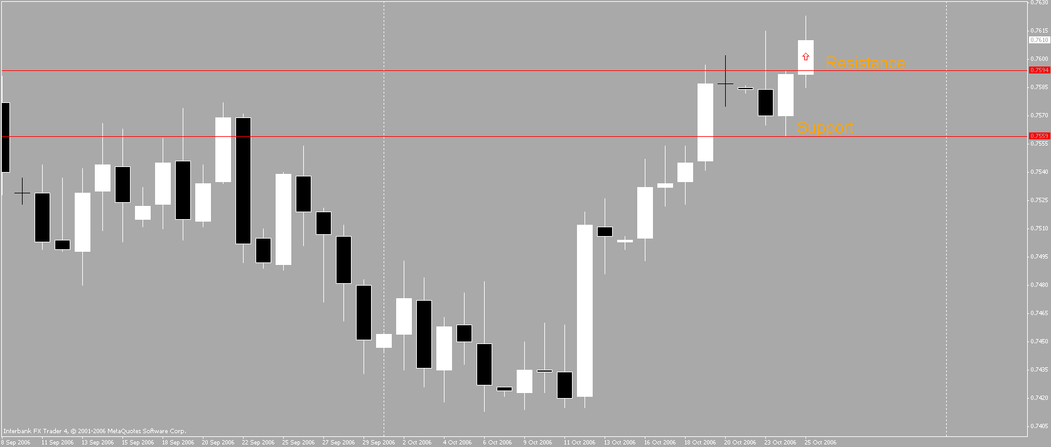

Now do this:

- Backtest on as many candles as you like, minimum 20 candlesticks
- Study the number of pips for every available trades (minus spread)
- How many candles give minimum 5pips?
- How many candles give more than 10pips?
- How many candles give less than 5pips?

Now you have the answer. ARE YOU EXCITED? You should be!

HOW TO TRADE THIS METHOD?

The Preparation

Upon the start of a new Daily candle;

- Draw the Support
- Draw the Resistance

….on yesterday’s candlestick please!

Draw the trend lines and determine the trend. This way, you can expect where the price will go. It is either towards the Support (bearish) or towards the Resistance (bullish).
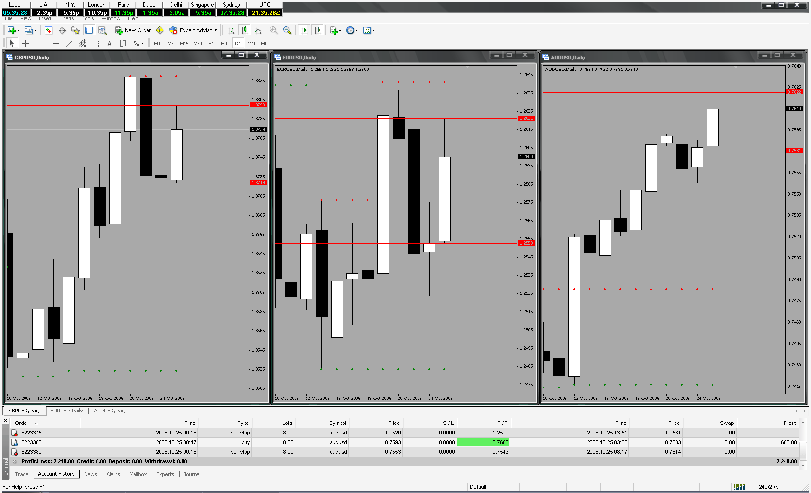

Taking the trade

It all depends on you, whether you want to babysit the trade or ready and leave the trade.

Either way, you can still profit from it.

Babysitting – Put a pending stop buy or/and stop sell orders. Wait until it penetrate either lines, move your stoploss accordingly and deploy traillock when you have to.

Ready & Leave – Like the above, but with an assign takeprofit and stoploss. I would recommend a 5pips or 10pips maximum. Why? Because, some bars only (very few) gives maximum 5pips.This way, losing trade is almost non-existance!

Things to remember and my recommendation only:

- Pick low spread pairs because of obvious reason.
- When placing pending orders, please don’t forget to include the spread + 1 or 2 pips as an extra precaution. Because sometimes the force is not with us (don’t want the order to be executed on the line and the price reverse!).
- Watch the monthly / weekly highs and lows. I would avoid a trade when it is near to the H&L. Price might reverse against your favour before it hits your takeprofit.
- Don’t trade to many pairs, maximum 3 pairs only, GBPUSD EURUSD AUDUSD. Why? Your margin might not allow it.
- I usually use stoploss of 20-30.

English is not my native language so please forgive my Yoda’s grammer and I hope you find the SUPPORT & RESISTANCE DAILY CANDLE method helpful and simple to use.

Welcome to Hapi Pipland!

